* The title, including a rough storyboard.
* A complete version of the game's story line.
* Any background information that will be provided to the user (perhaps to set mood, describe the historical or fictional context)
* The game's selling points (e.g. graphics, action, plot). I.e., what would make a game producer want to pay you to develop this game?
* A description of the primary modes of game play. E.g., your game might be primarily first-person, but have abstract modes when player is solving puzzle.
* For each mode provide:
  + A list of player resources, including how they are created and consumed. E.g., "bullets", "energy pills", etc.
  + The user interface. Provide a drawing/diagram.
  + Whether there is positive and/or negative feedback. I.e., what actions are good or bad for the player.
  + How you will balance the game play. What values can you tweak to make the game harder or easier? You should identify these up front so you can play-balance as the game's release date nears.
  + Storyboards demonstrating the mode.
* A transition diagram (like a finite state automata diagram) for how the player moves between the primary game modes.
* A description of all entities that will be in the game and how they behave.
  + Can the player manipulate them? Do they act as obstacles? What is their purpose? (Are they related to a goal, as an enemy, as scenery?)
* A description of all interactions in the game (e.g. which objects collide, which cause damage to the player)
* An inventory of artwork and models and how they will be used. If you are using sprites, indicate how many, and what they are to represent. E.g, "a sprite-set to represent a running zombie", "background for the night mode", "model of the climbing wall", "model of a cow", etc.
* A statement of how the work will be divided among the group members. Some roles and assignments might be obvious, such as, "Matt will provide all the artwork listed in Section 3.4. Sue will provide the model for climbing walls." Other assignments can be tricky: "Matt will provide the scripts that allow the player to climb walls." In this last case, Matt might have to coordinate closely with Sue.
* A timeline for your future work on the project. Look at the work statement. Consider what each team member is to accomplish, and decide how to decompose those accomplishments into doable, measurable subtasks. Make your best guess as to how long each will take to accomplish. Note which subtasks are prerequisites to other subtasks. Now try to arrange those subtasks into a horizontal sequence for each team member. Imagine vertical lines through the sequences to serve as your benchmark deadlines.
  + 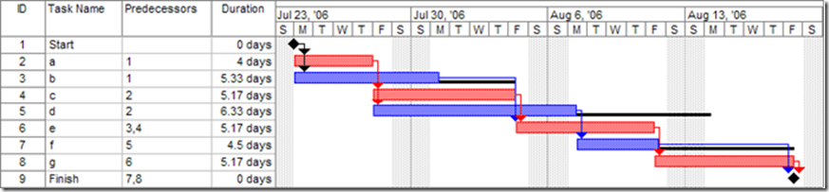Create a Gannt chart for the schedule. Each row of the chart should be a measurable task, annoted with names of the responsible team members. The columns indicate dates.
  + Make a timeline: each row should be a date, at least one per week. For each date, list what tasks should be completed by then, and who is primariliy responsible for meeting that benchmark.
  + Example: "October 1: Matt will provide initial code for player movement. Player animation can be minimal. Sue will provide models for walls and livestock. Tom will provide a terrain populated by trees and bushes."